|  |
| --- |
| Circle Language Spec: Black Boxes |

## Public & Private

#### Public Set / Access Connectors

The general notation of an access connector is as follows:

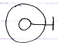

The sub-object is access controlled by the parent object. The line with the stick at the end is the access connector.

It is also the general notation of a *Public* access connector.

More specifically: it is a *Public Set* access connector, because it denotes, that you can make it point to something.

#### Public Get

The notation of the Public *Get* access connector is:

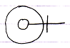

Because this denotes, that you can point *to* it.

#### Private Set

The general notation of Private is:

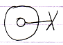

The cross expresses ‘inaccessible’ or better said ‘restricted’. Access is restricted to only a limited group of objects: the *friends*.

More specifically: it is a Private *Set* connector, because it denotes that making it point to something else is restricted.

#### Private Get

The notation of the Private *Get* access connector is:

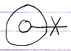

Because this denotes, that pointing *to* it is restricted.